Malta United Methodist Church
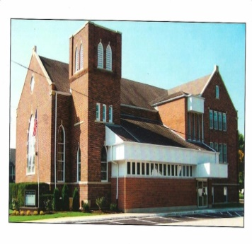
Malta United Methodist Church
201 E. Sprague Street
Malta, IL 60150

Malta
United Methodist Church
(815) 825-2118
201 E. Sprague St. (P.O. Box 158)
Malta, IL 60150
maltaunitedmethodistchurch@ outlook.com

Rev. Jeremiah Thompson, Pastor
Vicke Heins, Admin. Asst.

Annual Church Conference:
December 10, 2020 on ZOOM
at 7:00 p.m. & SPRC at 6:30 p.m.

Pastor Jeremiah’s Message
Find us on Facebook:
www.facebook.com/MaltaUnited MethodistChurch
When Megan and I first received appointments in this, the Northern Illinois Annual Conference of the United Methodist Church, I knew there would be some differences between where we’d served before in Central Illinois. New place, new policies, I find that’s true in any new job. But one of the policies filled my heart with joy and hope. It was called “Way of Christ.” In our conference each church is trained in a method of talking about potentially difficult issues. Issues where there might be conflict or strong differences of opinion. This is based in Matthew 18:15-17, where Jesus lays out ways to first address difficulties, and secondly to continue to love people even if full resolution is not reached.
The rule of Christ training encourages people to talk to each other directly, openly, and lovingly about concerns. For instance (and this is all hypothetical not from our own church) if a change is made in the time of worship and someone has serious concerns about it, they should go to the worship team that made the change and talk to them. Rather than talking to others around the church, but not the people who made the decision. Directly talking about problems or stresses rather than letting them build up is Christ like, healthy, and helpful. This sort of action can also be hard as many of us avoid difficult conversations. Some people are even taught not to have them. But only through speaking truth, in loving honest ways, with God’s help can resolution be found.
I thought about this Rule of Christ program and training as we near the election particularly. Before 2020 the US had great division in society. The stresses of this year with Covid-19 first and then heightened calls to fight racism, on top of a contentious election have led to further divisions. There has been a great deal of conflict in our nation, and possibly between us and our neighbors, friends, church family, or family. So, as followers of Jesus Christ, what are we called to do?
I believe we need to listen to each other more. If we are concerned by someone’s words or actions, we need seek to understand them and also work to help them understand where we are coming from. This could be over some political issue, or it could be concerning a decision made at work or in our families. The point is we should lovingly try to listen and communicate, rather than just avoid or grumble to others. This is not easy, and frankly your pastor writing this article is struggling to live into this fully too. However, I believe in this we are playing the role of peacemakers. Christ said blessed are the peacemakers, and when we work through misunderstandings or conflict we live into this calling from Jesus. So, who might God be calling you to talk with, to understand them, to work for resolution? Let’s be peacemakers in the ways we can in the midst of a divided time, may it be so in Jesus’ Name, Amen.
In Christ,
Pastor Jeremiah

PASTOR JEREMIAH AWAY!
I, and my spouse Megan are taking a few days off from October 5-8 to go to a cabin in the woods and get “off the grid” for a few days. While we are away enjoying the lake and the fall leaves, should there be a pastoral emergency, Pastor Dave Rogula from the Esmond UMC is covering for me. You can reach him at 815-994-2509.
Blessings and peace, everyone, Pastor
OCTOBER 2020
Vicke, Admin. Asst. Hours: M-W-Th 8:00 – 12:00 p.m.
Sunday | Mon | Tues | Wed | Thur | Friay | Saturday
 |  |  |  | 1 | 2 | 3
4 Indoor  Worship  Begins 9am  Crop Walk | 5 | 6 | 7 | 8 | 9 | 10
11 | 12 | 13 | 14 | 15 | 16 | 17
18 | 19 | 20 | 21 | 22 | 23 | 24  with Pastor Jeremiah
25 | 26 | 27 | 28 | 29 | 30 | 31
At midnight on Saturday, Oct. 31st
TURN YOUR CLOCKS BACK!
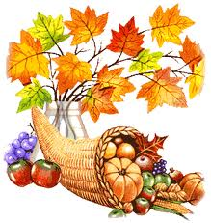
Fall Roast Beef Dinner tickets can be purchased from Vicke in the Church Office on Mon-Wed & Thurs
from 8-12.
Please have the exact $, or bring a check
made out to Matla UMC / Note: Roast Beef Dinner!

ANNUAL CHURCH CONFERENCE
Thursday, December 10th at 7:00 p.m. / SPRC 6:30 p.m.
The District Office must have all reports in their
office by November 26st .
If you are having Vicke do your reports, they must be in the church office on or before November 20th
If you are sending in your own reports, District has asked that you use the churches email address (maltaunitedmethodistchurch@outlook.com)
“instead of your own”.
Also you need to send a copy to the church office,
prior to submitting the report.

The District Superintendent, Rev. Brian Gilbert, invites
everyone to attend the Annual Church Conference on Zoom. It is NOT just a meeting consisting of many reports – it is a CElebration of your church and its HOPE of accomplishments for the future.
ANNUAL CHURCH
CONFERENCE WILL BE

ON ZOOM!
More information will be coming regarding zoom!
Sunday, October 4th
Crop “Hunger” Walk

Due to Covid, you can walk on your own and ask for donations OR you can make a Crop Walk donation by sending your check (Made out to CWS/Crop for Malta U.M.C.) to Ruth A. Hueber at
303 S. First Street, Malta, IL 60150.
Thank you for supporting this cause, sponsored by Church World Services (CWS) to raise funds to
end hunger in the U.S. and around the world.

__________________________________________________________________________

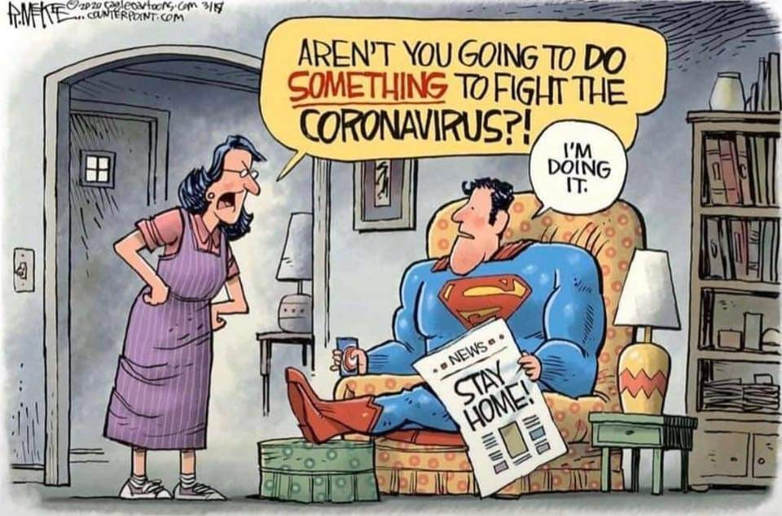

 | NOVEMBER
6 | Ruth Hueber
11 | Madeline Hill
12 | Vicky Vint
14 | Dorothy Stoddard
19 | Annika Anderson  McKinzie Anderson
20 | Myrna Dodge  Kevin McArtor
22 | Dawn Cook  Jerry Jordal

 | OCTOBER
1 | Alexandra Heuber-Walsh  Brian Fucilla
3 | Norma Hopkins  Gerald McArtor
5 | Rodney Hueber
7 | Mary Lou Hueber
11 | Marcia Hueber
13 | Sue Plote
14 | Tim Carter
16 | Jacob McArtor
17 | Paul Butler
22 | Brad Garrett
25 | Steve Sandberg

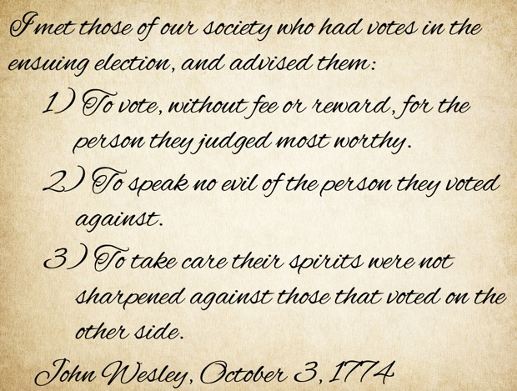
 | DECEMBER |  | 2020
2 | Brenda Hunt  Jalen Jouris | 19 | Austin Arndt
8 | Joanne Abbott | 21 | Donna Willrett
10 | Frank O. Jouris | 22 | Max McArtor
12 | Katie Crouch | 23 | Abiella Thompson
14 | Kaye Dinsmore | 29 | Joanne Hackbarth
16 | Joel Hueber | 30 | Carol Sandber
WATCH OUT FOR SCHOOL BUSSES & CHILDREN
IN OCTOBER
Special ED – Oct. 12th
K-5 – Oct. 26th
ARE GOING BACK TO SCHOOL!

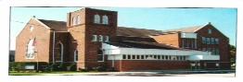
Mark YOUR CALENDARS
and sharpen your selling skills!

We are having our annual Fall Roast Beef Dinner on Saturday, November 7, 2020. With all the challenges we have faced this year in 2020, this will be a time for us to come together as a community to support each other and our neighbors. Our dinner this year will look a bit different, as it will be drive-thru only, with the same hours 4:30-7:00 pm.
Our menu remains the same, Roast Beef, Mashed Potatoes, Gravy, Sweet Peas, Jello Salad, Rolls, and Pie. Ticket prices will remain the same (Children age 7 and under $5.00; Adult age 8 and up $15.00; and King Cut/Double Meat $20.00) and will be sold through church members as in the past. Tickets are currently being printed and should be available for distribution by this weekend, the 3rd weekend in September.
Due to health limitations, there will be no beverages served, no bake sale, and no homemade pies. Pies are being limited to four kinds to keep our menu simpler for filling orders and are being made in licensed commercial kitchens or purchased commercially.
We were not able to hold our annual Bake Auction this year, so this looks like it will be our only fundraiser for our church. We are asking everyone to go the extra mile in selling tickets! We would also ask that you consider monetary donations in lieu of bake sale items and pies that you may have donated to offset the loss of those items this year.
Although this year will be different (like many things we have experienced!) but we can do this! We appreciate your support and look forward to another successful fundraiser.
Blessings to all, Jacque Fucilla and Jodi Slade
Fall Supper Co-Chairs
WELCOME BACK TO CHURCH Oct. 4th
MALTA UMC CHURCH PROCEDURES
Dear Malta United Methodist Church Family,
Greetings in Jesus’ Name, I hope this email/letter finds you well. I want to let you know about the many options for worship that will be available starting on Sunday October 4, and likely lasting for several months, until a vaccine for Covid-19 is widely available.
First, we will have scripture reading and sermon posted on our Facebook page, and my YouTube page each weekend, we also may have some videos with music or other things posted from time to time. If you cannot safely leave your home, are laid up, or busy during worship on Sunday mornings these options are always there, and we welcome feedback and comment on them always. I intend my sermons to be the start not the end of a conversation so please let’s be in conversation in the ways we can.
Secondly, we are going to try out a short-range FM radio transmitter. This would allow a person to listen to the worship service in their car through their car radio if they are in the church parking lot or near the building (within 200 yards of the transmitter roughly). It’s not the same as gathering for worship in the building, but we want to try this option if it would be one some of you would like to try.
Third, we are going to try to have a live Zoom broadcast of our worship service, if you cannot come to the building for reasons of health, and or are out of town but want to worship with us, we will keep this option available indefinitely.
Fourth, we are happy to mail you the sermon each week, some of you have already been receiving it, if more of you would like to receive it please let Pastor Jeremiah know, 815-592-3764.
Finally, beginning October 4, we will have in person worship inside our building, however to keep this safe for everyone we have to have several policies in place, so here they are, please if you plan to attend read these over carefully.
List of Policies and Procedures for Worship
in the Sanctuary Fall 2020
- Do not come to worship if you are feeling sick in any way, this above all else will prevent the spread of germs of any kind. Hopefully if you are feeling poorly you can connect to worship one of the ways above.
- All those entering the building must be masked unless they are an infant (we have masks available in emergencies, but please bring your own if possible)
- We will have someone keep a record at the door of who attends worship (we must do this so that if anyone should become sick we can let others know they need to be tested), also this person will need a phone number from people if we don’t have it already.
- People can then enter the Narthex, but we ask them to maintain social distance (6 feet apart) with those they did not arrive with (if you rode in the same car with someone, and or share a home with someone you can be as close as you want)
- An usher will then escort people to their seats, ASAP with one pew distance between those in front and behind, and 6 feet of distance between groups in the pews, feel free to talk with others near you, but please maintain social distance and stay in your pew unless you need to use the restroom.
- The drinking fountain must remain off limits, so if you think you’d like or need something to drink please bring it with you in something as spill proof as possible.
- At the door to the sanctuary we will have someone handing out whatever is needed for worship (sheets with liturgy printed, communion elements, etc.) This person must be wearing food service gloves or better!
- We will at the back of the sanctuary have an offering plate set out that people can drop gifts in as they pass before or after the service
- When the service is ended, people will need to remain in their seats until escorted to the door by the ushers, we need to ask people to not gather for conversation in the Narthex as it will make social distancing difficult, please head out to the parking lot, and either leave or talk there again with social distancing.
- Pastor will with social distance greet people as they leave, however these won’t be able to be long conversations so please if you’d like to talk to me about anything give me a call (815-592-3764, or email me at castiger1@gmail.com)
- When everyone is out of the sanctuary those cleaning up after worship can wipe down surfaces (pastor will take care of the pulpit area) and then we can head home.
I want to say the fact that we cannot fellowship as we would normally, the fact we can’t do Sunday School, the fact that we can’t do coffee as we would normally, the fact that we can’t have congregational singing as we would normally, these grieve me, and I believe grieve many of you as well. We are living in a difficult time, and some of those things we enjoyed, and or which gave comfort we cannot do for the sake of looking out for each other. It’s okay to mourn that, or be frustrated, or feel something else, Jesus loves us when we aren’t happy, and God asks us to cry out to god when we need to. However, in the ways we can, and in new ways that God will show us through the Holy Spirit we can still grow deeper in our relationship with God, we can still be shaped by Jesus Christ, we can still play our role in the world being remade through God’s love.
If you have any questions or concerns please call or email me, we want to avoid confusion as much as we can.
Blessings and Peace Siblings,
Pastor Jeremiah Thompson

Governor Pritzker and the Illinois Department of Public Health (IDPH) are announcing COVID-19 resurgence mitigations will be implemented in Region 1, the northwestern most counties in Illinois, beginning Saturday, October 3, 2020. In the past week, Region 1 also had an early indication of increasing hospital admissions for COVID-like-illness. Although this increase has not yet reached the threshold level, it indicates more severe illness is increasing and IDPH will continue to monitor the region's hospital capacity.
Mitigation measures taking effect October 3, 2020 in Region 1 include the following: Bars• No indoor service Restaurants • No indoor dining or bar service
These mitigations do not currently apply to schools.

